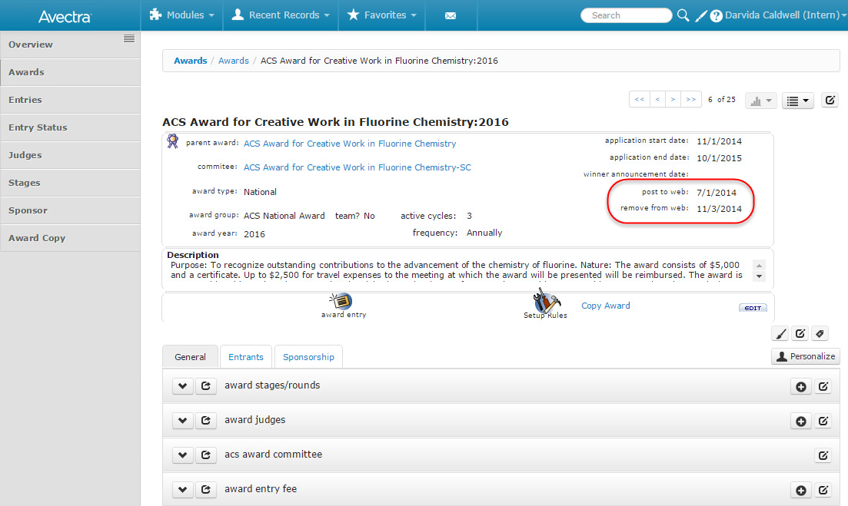
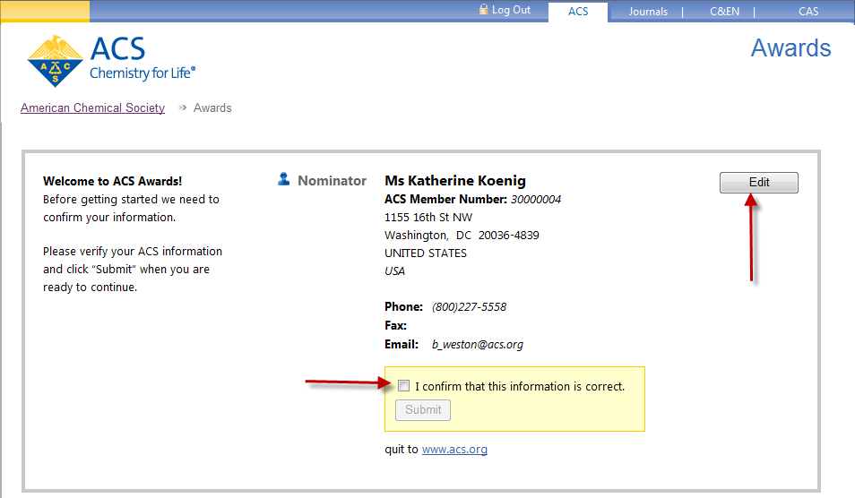
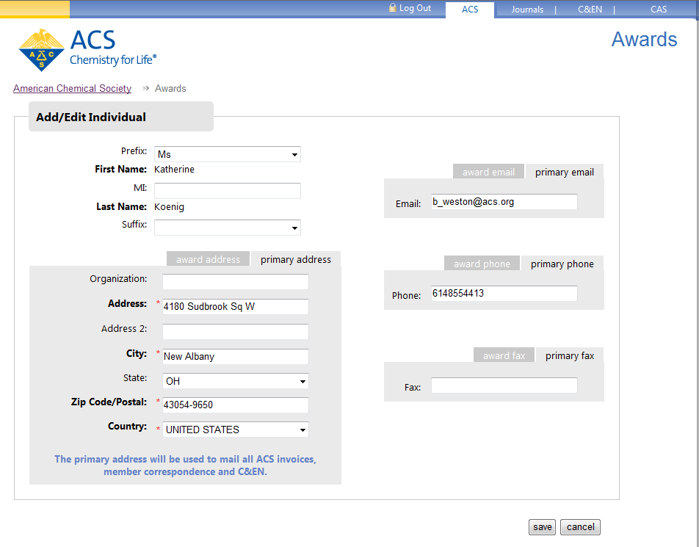
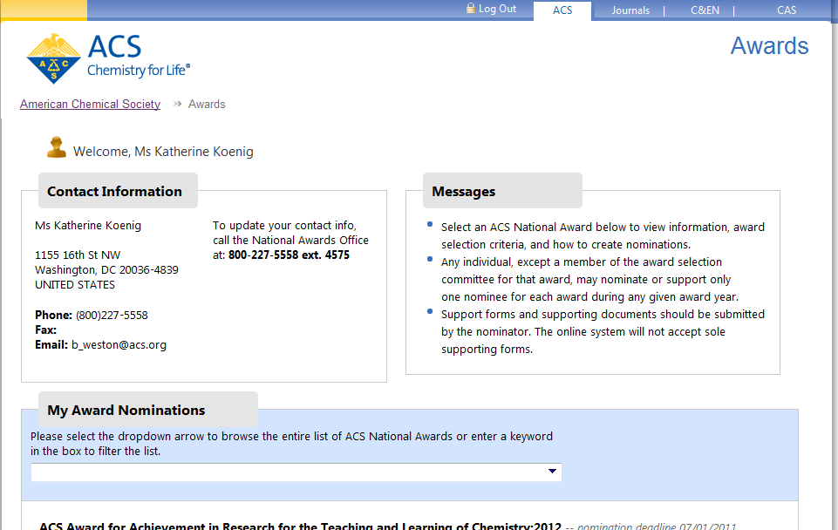
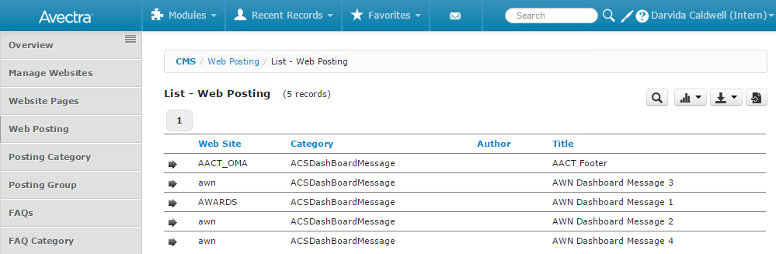
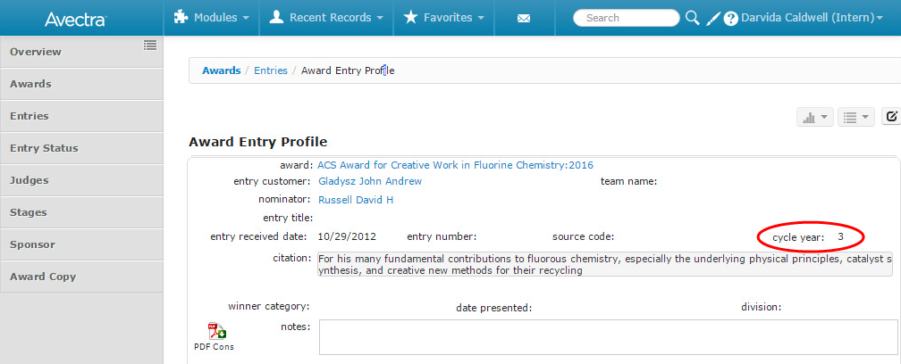
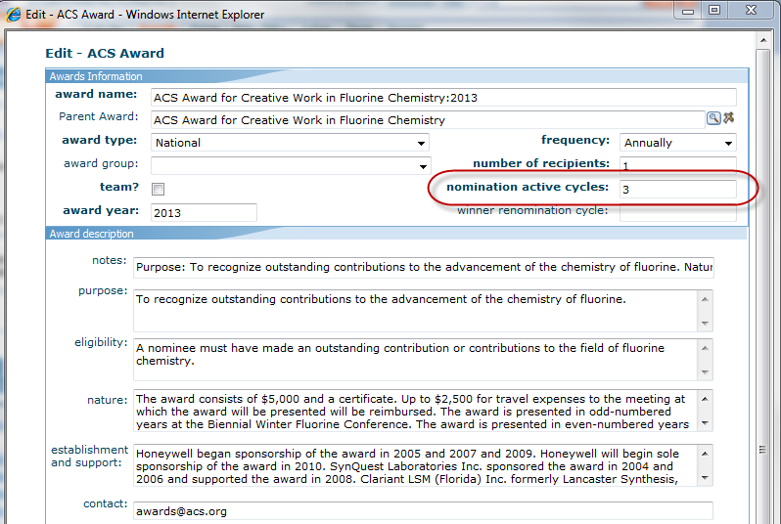
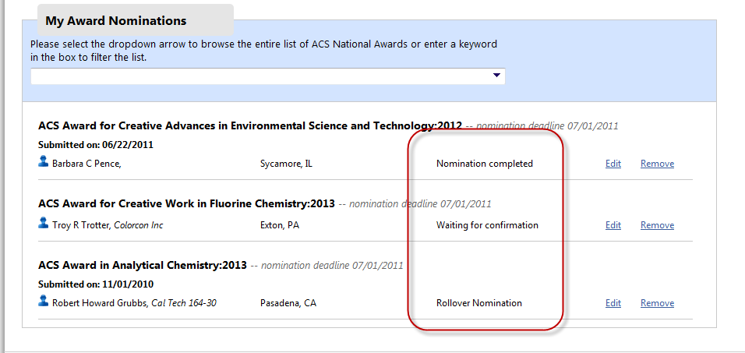
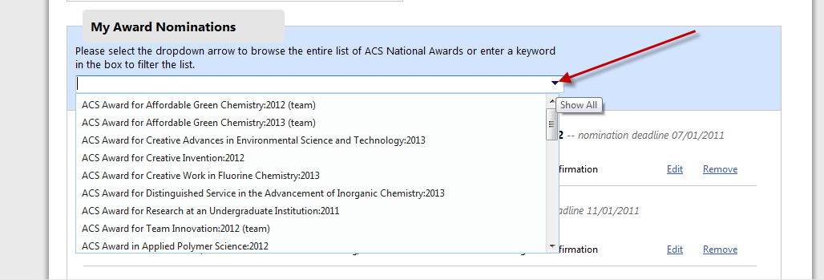
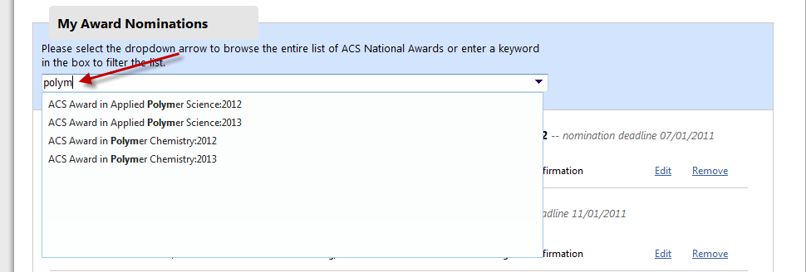
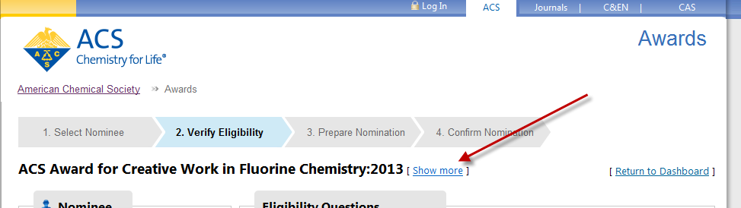
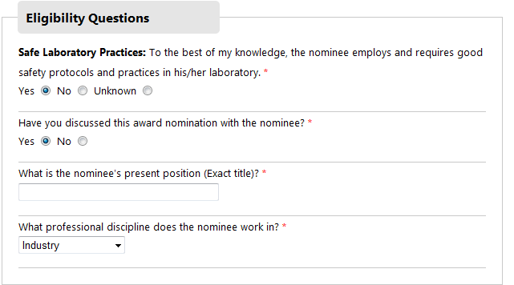
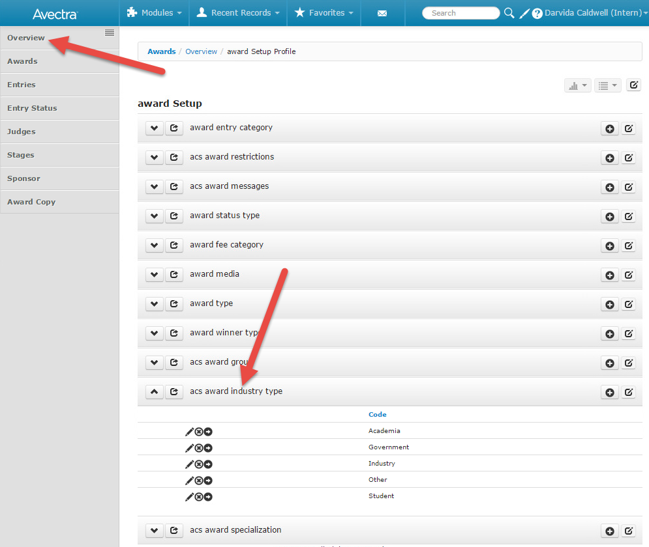
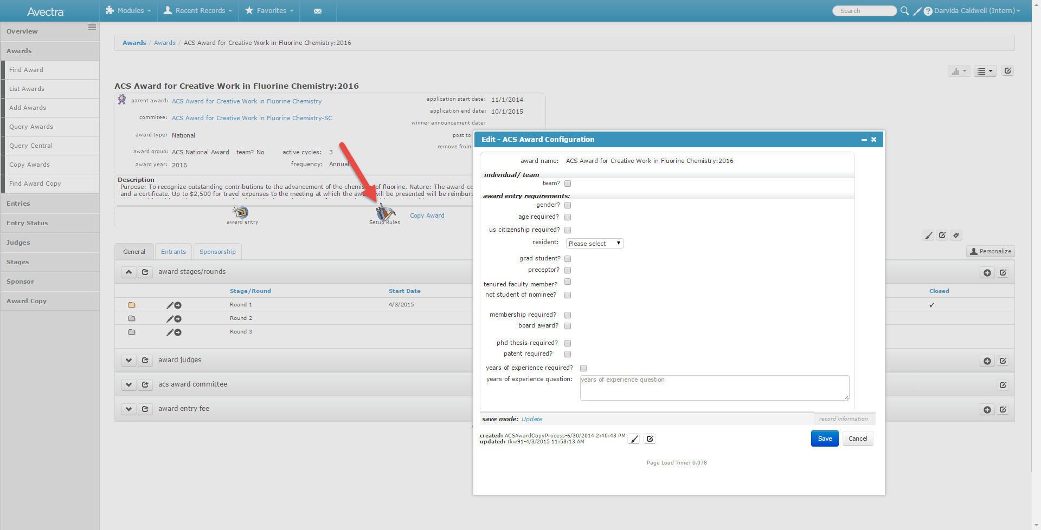
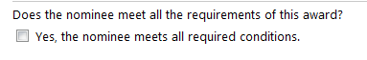
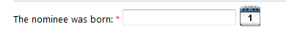
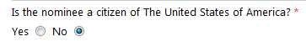
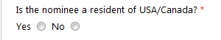
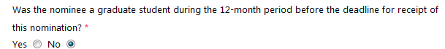
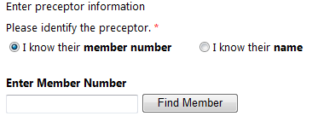
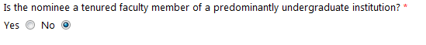

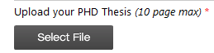
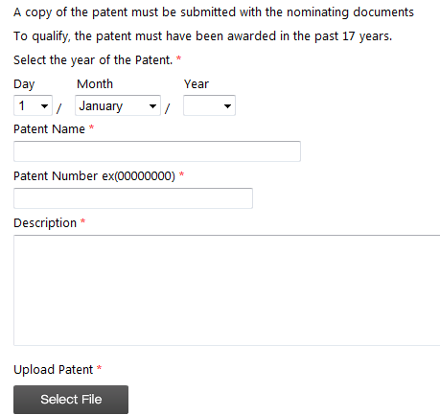
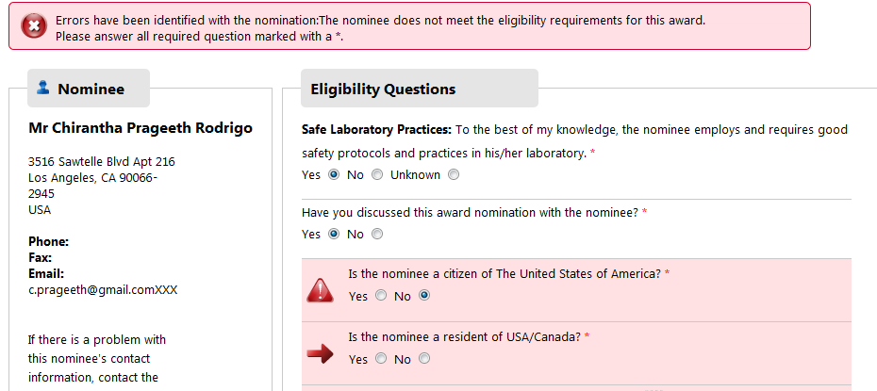
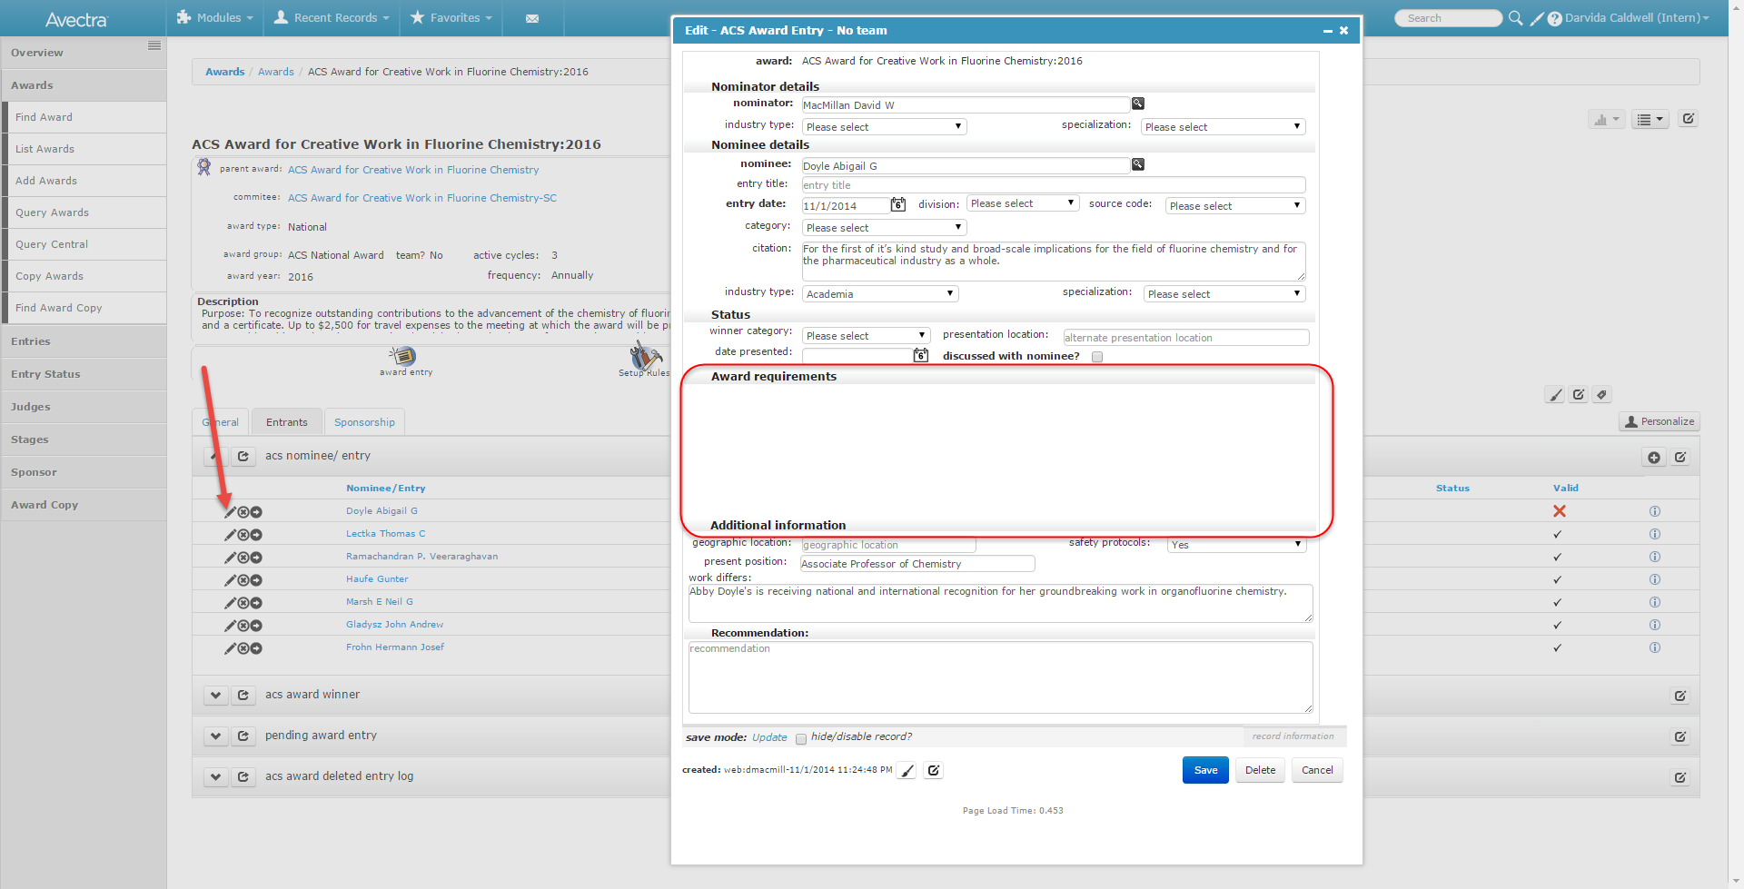
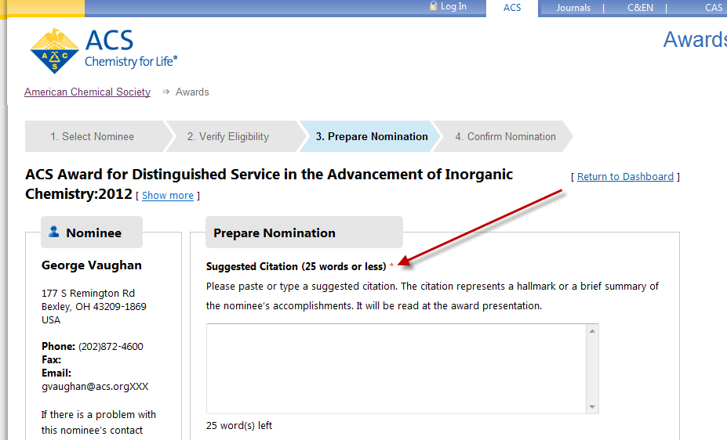
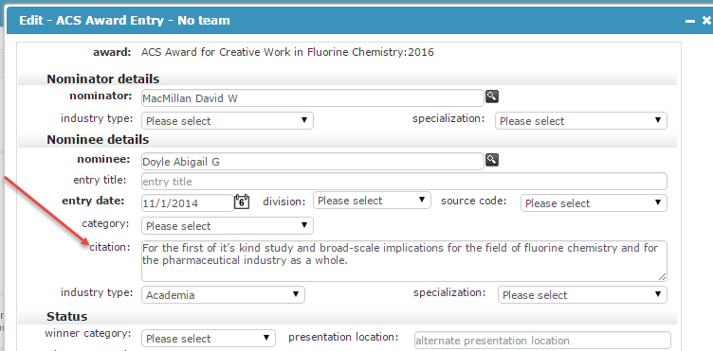
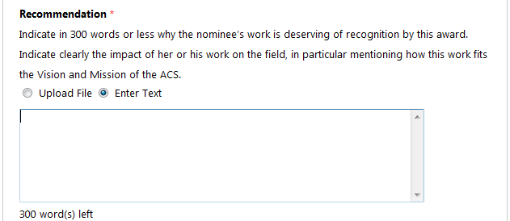
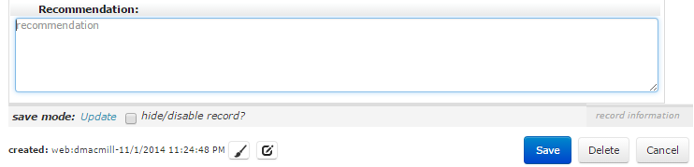
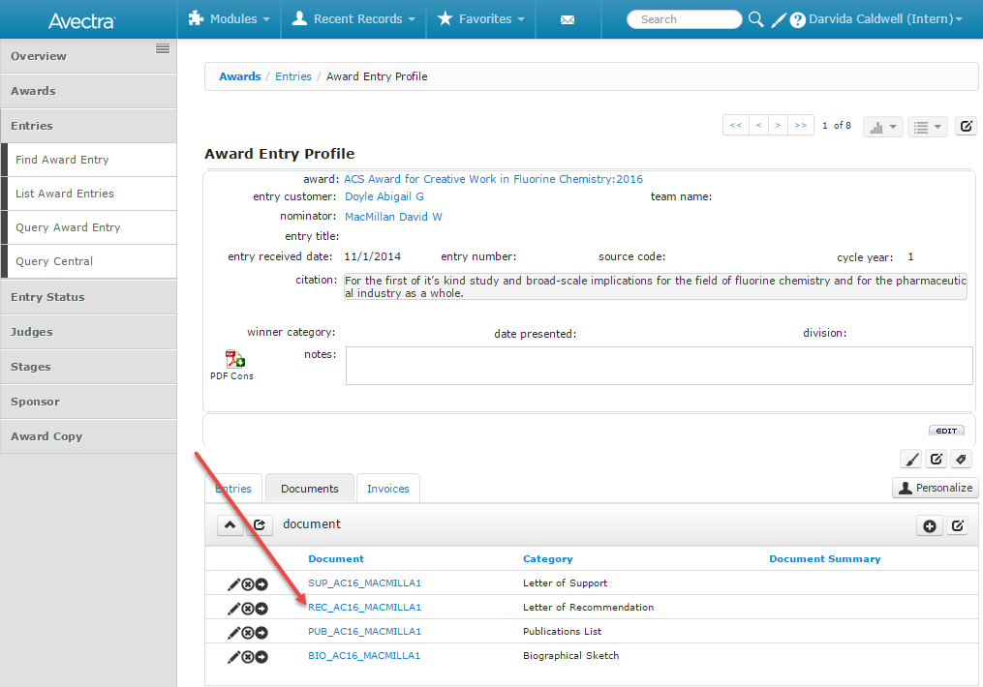
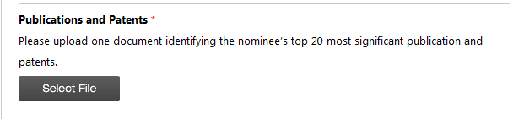
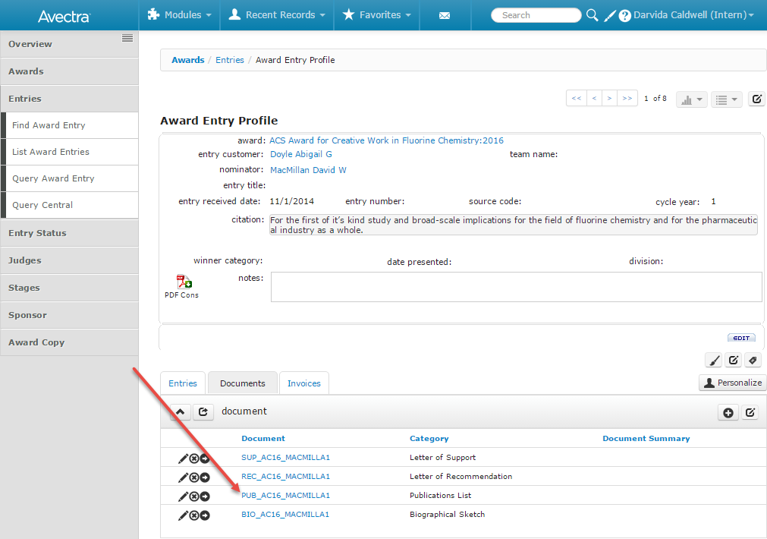
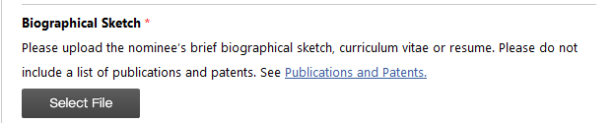
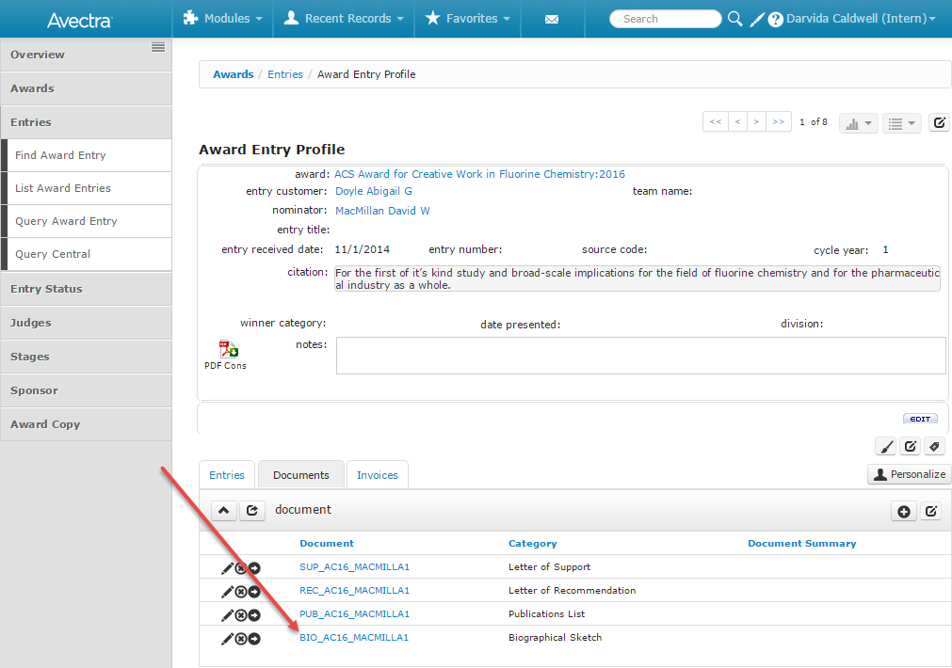
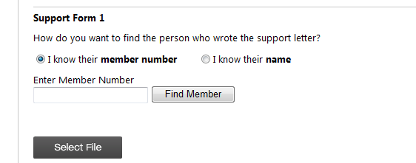
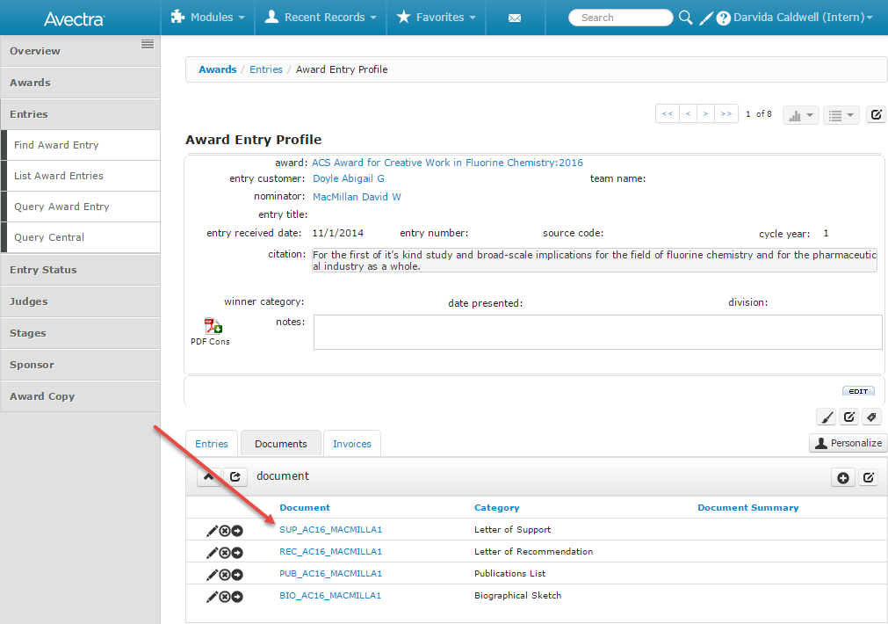
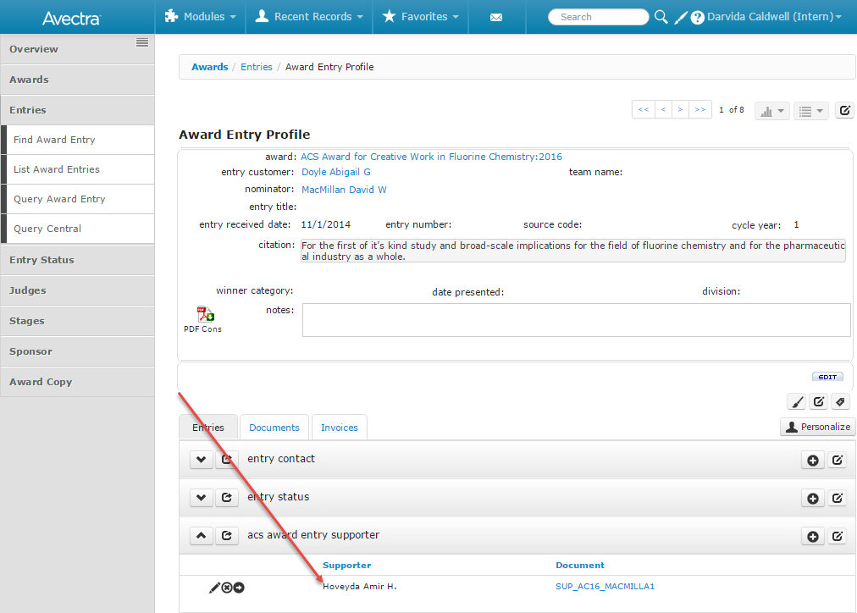
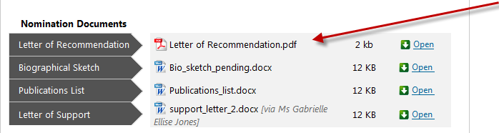
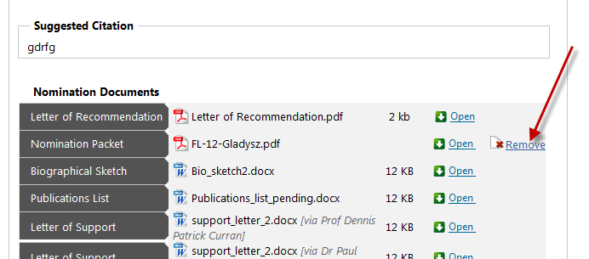
Nomination Application – Individual Nomination
Award Visibility:
The visibility of the awards in the application is determined by the award “post to web” and “remove from web” dates. If the current date falls between these 2 dates assigned to an award, then that award will be visible.
The awards are not visible if these dates are null.
Log into the Nomination Application:
In netFORUM the awards module is only visible to the Awards Department and Administrators. There is sensitivity surrounding the ballots so if others need to view/use this module we will need to figure out a way to restrict access to the ballots.
The URL for the ACS National Awards Nomination Application is: https://www.nominate.acs.org. On the Sharepoint site, go to National Award Site, Shared Documents, Training folder, Nomination_application folder, momination_application_test.docx for the instructions on how to change the Login page text.
A nominator will log into the Nomination Application by either using a combination of Last Name and ACS customer number or ACS ID and password. Nominators are both members and non-member.
Every 365 days, the nominator will be required to “confirm” the contact info on file – see ACSAwardOnlineNominationAccountInfoTermLengthfor number of days. If a nominator has a contact info with a type of awards it will be the contact information displayed on the address confirmation page, otherwise the primary info is listed.
Selecting Edit will allow the nominator to change the primary and/or award contact information that is currently in netFORUM. They could also create new awards contact info.
Award Dashboard
The award dashboard will display the Nominator’s Award contact information. If no Award contact info is in netFORUM, the primary info will be displayed.
The text in the messages area is stored in netFORUM and can be easily changed. This text is located in the CMS module, Web posting area. They are identified by the category “ACSDashBoardMessage”.
If the nominator has any active nominations, they will be displayed in the body of the dashboard page. New and rollover nominations are visible. New nominations are those that were created during the current award year. Rollover nominations are those that were copied from the previous award year into the current year.
New nominations have a cycle year of 1. Each time the nomination rollovers, the cycle year will increment by 1. Nominations will rollover 2 times; therefore nominations with a cycle year of 3 will not rollover again.
Nobel Laureate nominations are only active for 1 year and do not rollover.
The “nomination active cycle” located in the Edit Award window indicates how many times a nomination rolls over.

There are 3 statuses for the nominations.
- Rollover nomination – an award created during a previous award year and copied into the current award year; award materials are saved in netFORUM
- Nomination Completed – Nomination has been submitted and most recent changes/creations/edits copied to netFORUM; award materials are saved in netFORUM
- Waiting for Confirmation – Nomination is residing in the pending tables. Will not be written to netFORUM until the nomination is submitted. If a nominator selects the “edit” button for a rollover nomination it will automatically change to “Waiting for confirmation” even if they do not make any changes and just review the existing rollover nomination.

Select the Award:
There are 2 methods that can be used to select an award. One way is to select the dropdown arrow in the award search box to browse thru all valid awards.
The 2nd method is to type a keyword into the award. The awards will be filtered based on the text entered.
All nominations must be submitted by the Award Deadline for consideration. Prior to submitting the nominations are stored in pending tables and are not committed to netFORUM until they are submitted. Any edits are also stored in pending tables and don’t write to netFORUM until they are submitted.
Pending nomination documents are located: \\acs.org\Applications\NAS_Prod_NetForum\NetforumData\Awards\Documents
Submitted/Final nomination documents are located: \\acs.org\Applications\NAS_Prod_NetForum\NetforumData\Awards\Documents
An award will not be available for selection (ie. not visible in the award list) if:
- Nominator already has an active nomination
- Nominator is on that award’s selection committee

Identify the Nominee:
A nominator nominates someone else for an award – they do not nominate themself. A nominator will search netFORUM for the person he/she wants to nominate. Nominees are both members and non-members although there are a few awards that are restricted to ACS members. They can search by ACS customer number or by name. To search by ACS member, select the “I know their customer number” and enter the customer number into the search box. Clicking the “Find Member” button will find the nominee. To search by name, select the “I know their name” radio button and type the nominee’s name in to the search box – it does not matter in what order the name is. Click the “Select Nominee” button to continue the application. Deceased customers will not be included in the search results.
A nominee cannot be nominated for an award if he/she:
- has already been nominated for that award
- is on the selection committee
- is a previous winner of that award
In all cases, the nominator will be informed that the person is not able to be nominated for the award, and therefore the nominator cannot continue.
If the person is not found in the netFORUM, a new customer record can be created for the nominee by the nominator. The “Create a new nominee” button is only visible after a “I know their name” search has been performed. Basic name and contact information is required for the new customer record. These new customer records will be saved with an address type of awards.
Eligibility Questions:
The “show more” link when clicked, displays the award criteria and requirements.

All questions on this page are required. Based on the answers to these questions, the nominator will be told if the nominee is not an eligible nominee for the award. There are 4 standard questions that are visible for all awards:
The selection options for the profession discipline are located in the awards setup area under the “acs award industry type” childform:

The other award specific eligibility questions are dictated by the Award eligibility requirements found in the Award Setup area.
Selecting the following specific Award eligibility requirements in the Award setup area will result in the following question’s visibility on the page:
Team: | No question visible – determines that team functionality will be used by the nomination application
Gender: demographic questions such as gender cannot be answered by the nominator so the question was modified
Age required?
US citizenship required?
Resident? | If USA selected in dropdown box, question will ask instead: Is the nominee a resident of USA
Grad student?
Preceptor?
Nominator will search netFORUM to find preceptor. Uses same functionality as nominee search.
Tenured faculty member?
Not student of nominee?
Membership required? | No question visible but nominee’s membership is validated during the select nominee step
Board award? | No question visible – used for voting purposes
phD thesis required?
Patent required?

If a nominee does not meet a requirement or a required question was not answered, the nominator will be notified after clicking either the “Save for Later” or “Continue” button. The problem question will be highlighted in red.

In netFORUM, these question/answers are stored in the Nomination profile.

Prepare the body of the nomination:
If the upload buttons are not visible it may be because Flash is not loaded on the computer.
Citation –
Enter a suggested citation for this nomination. There is a 25 word limit on the citation.
The citation is stored in the Nomination profile
Recommendation –
Either enter text in the text box or upload a document that explains in 300 words or less why the nominee is deserving of recognition by this award. To upload a document, click the “Select File” button and browse to the document. Documents are restricted to Word or PDF formats.
If the recommendation is entered as text it is stored in the Nomination profile. The text will be visible in a PDF format on the Application Confirmation page and in the Awards voting application but it is stored as text in netFORUM.
If the recommendation is an uploaded file, it is listed in the documents childform for the nomination.
Publications and Patents-
Upload a document that contains a list of up to 20 of the nominee’s most significant publications and patents. To upload a document, click the “Select File” button and browse to the document. Documents are restricted to Word or PDF formats. The publication and patents list is required.
The file will be listed in the Documents childform of the nomination.

Biographical Sketch-
Upload the nominee’s brief biographical sketch, curriculum vitae or resume. To upload a document, click the “Select File” button and browse to the document. Documents are restricted to Word or PDF formats. The biographical sketch is required.
The file will be listed in the Documents childform of the nomination. In netFORUM documents with a category of Biographical sketch, CV and resume are all considered biographical sketches.

Supporter and Support forms-
As with the nominee, the nominator will be searching the netFORUM to identify the supporter for the nomination. If the supporter is not located in the netFORUM, the nominator can add a new record for the supporter.
A person cannot be a supporter if he/she is:
- a supporter for another nominee of the same award
- the nominator
- the nominee
The nominator will be notified if any of the cases are met and will not be allowed to select the person as a supporter. If a supporter is identified, a support letter must be uploaded and vice versa.
To upload a document, click the “Select File” button and browse to the document. Documents are restricted to Word or PDF formats. The supporter and support letters are optional. Only 2 supporters are allowed.
The file will be listed in the Documents childform of the nomination.
The supporter name will be stored in the Entries tab in the “acs award entry supporter childform”. The link to the document does not work from this childform. Use the link located in the Documents tab to view the Support letter.
Select the Continue button to advance to the next page of the nomination.
Confirm the Nomination materials are correct
Any changes can be performed by selecting the “Go Back” button.
If text was entered into the recommendation field, that text has been converted into a PDF and will be visible on the confirmation page as a PDF.

For those nominations that were imported from the existing Awards database, they will contain a file that contains all of the nomination materials. From the confirmation page, the nominator is able to delete this packet from the system.

Once the nomination is complete and all materials are correct, select the “Submit Nomination” button.
When the nomination is submitted, the nominator will receive an email confirming the receipt of submission.
Up until the award deadline, the nomination has the ability to return to their dashboard to make any additional edits or changes to the nomination.
All nominations must be submitted by the Award Deadline for consideration. If not submitted by the deadline the nomination will not be saved into the Award (it will remain in the pending table) and will therefore not be considered a nomination.
Pending nomination documents are located: \\acs.org\Applications\NAS_Prod_NetForum\NetforumData\Awards\Documents
Submitted/Final nomination documents are located: \\acs.org\Applications\NAS_Prod_NetForum\NetforumData\Awards\Documents

